**Why is testing so important in Retail, how to do it right**

The way to commence this topic is to understand the retail domain first in a nut shell and then proceed with the impact of IT on the business and importance of testing in the retail domain.

**What is Retail domain?**

Retail can be explained as a branch of supply chain industry, which is about selling the merchandise to the customers. In return through point of sales these retailers expects returns in terms of revenue

This industry started with a single channel business model, where they have physical stores, inventory and operates from one specific location. It is customer’s responsibility to walk in and get the goods. In this model the industry has very less chance for diversification and business expansion as their reach to the other world is very narrow.

Over the passages of various industrial revolutions and with emerge of digitization and emerge of various technologies, retail industry has hopped and started using these platforms for their business. From single channel to multichannel then subsequently to the Omni channel model. Due to which the industry is in everyone’s pocket and the retailers were operating from everywhere, thanks to the technology that these retailers were able to organize, synchronize the order management and the shipping process and gaining the customer feedback. For every purpose we have an IT solution for the retailers to track.Given below is one sample scenario as how Omni channel industry operates

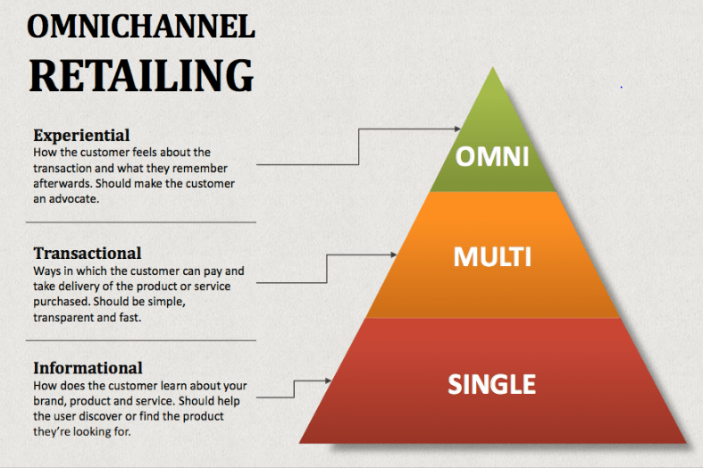

Figure: Retail industry operating model types

**Eg:** The Omni channel model can be explained as, customer watching something in an advertisement on television and searches for it over the web and orders I through the shopping site and now the POS (point of sale) or the retailer has to co-ordinate and identifies the product and ship I for the customer. In this process we have organized so many things such as managing the digital data about the customer and about the product then handing it off to the seller, then seller who actually gets from the inventory and ship it to the customer address.

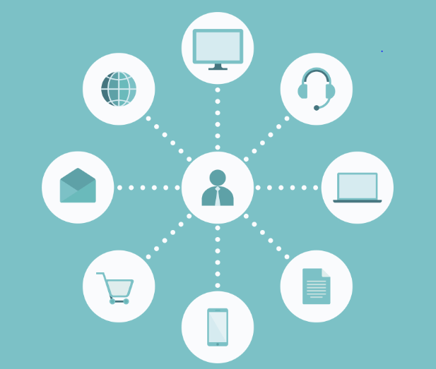

Figure: omni channel operating model

**Role of Technology in Omni channel retail industry**

Having understood the business model on retail industry, one must understand that without digital platforms the business can never exists. Technology has been helping and finding lot of ways to grow the business. Below are some key platforms that Omni channel retail industry uses to proceed with its regularities.

* Mobile/ web based business applications
* POS applications
* Social websites to publish advertisements
* Advertising on vivid web sites
* Payment gateways / banking related apps to process the fund
* Shipping process tracking applications

If we look at the above IT solutions that retail uses, we should now be really concerned about these applications softwares. Given the degree of dependency if at all these systems neither properly designed nor validated the business loss is going to be humongous. Hence we must ensure that these systems are perfect and flawless before we suggest retail to use. Honoring the topic of this discourse we will emphasize the need of testing.

**Why is software testing is important?**

As we aware software testing is the process of validating application system software for its correctness and its consistence. This comes true with the retail domain applications as well, let’s understand thoroughly the importance of software testing

In the Omni channel retail model we understood that the business can happen anywhere due to the availability of online platforms. The retail system is quite complex process it involves in

* Promoting the products on the portals
* Receiving the orders
* Processing the fund (inbound/outbound transfers)
* Managing the shipping process
* Doing market analysis and getting customer feedback

All these things are managed by different applications as we understand since these are relying on these systems, testing of these domain applications is essential.

Also the most common problems that the retail industry can face due to its applications are

* Poor performance of the application which annoys the customer
* Poor UI/UX design that doesn’t buy the customer satisfaction
* Security breaches and vulnerabilities as we process customer related data
* Any malfunction that impacts the business

Considering the complex process of the business model and the possibilities of getting into aforementioned problems, we should understand the need of testing. Testing reveals any defects that are present in the system that we can ensure the application functions as intended. These applications lays foundation to make huge business, any flaw in the system can lead to derogatory. Ultimately the firm ends up in losing the business as well as returns

The reason behind biggest success of retailer giants amazon , flipkart is having an efficient systems and utilizing the technology to the bits

**How to achieve the more test coverage in right way**

While we understand the need of testing for the retail application, let’s also look into how to do the testing right and what are the types we need to be performed.

As per one of the testing principles **exhaustive testing is impossible** therefore we should have concrete test plan and the strategy such as

1. How many different levels of testing to be done?
2. How many environments to be used before launch?
3. Assessing the test risks and having a mitigation plan

Prioritization of test types is must. This will help us to validate the functionality of the application as per the agreed timelines without compromising the quality

**Types of testing needed for retail application**

**Unit testing**

Considering the new agile practice and TDD approach in mind, unit testing is must. This test usually done by developers. In TDD production code is not written until the tests are built and seen failed. Unit testing confirms the code coverage, path and conditional coverage. Fixing of any bugs found here are very cheap and could be fixed easily. Also in the recent days everyone started building their applications in micro service architectural style, so as soon as an individual component is built testing of it is necessary. This approach not just helps us finding the bugs but help us prevent the bugs that may occur in higher environments. This gives us confidence that we are building the product right

Eg: writing Junits, N-units to test the code

**Contract/Integration testing**

After ensured that a particular component working as intended when it is tested as standalone service, now in this phase we will integrate these smaller components then test the communication between them. Some of the components might have not readily available for testing but still creating stubs and testing the required services would be good approach

One of the recent testing approach which is consumer driven contract testing can be used to test this. This helps us start testing the APIs both external and internal before even they were built. Also the tool generates tests for us which would be played against the real API once it is available. These tests will give very faster feedback

**API testing**

API testing is very essential since an API is the one which is going to perform the business logic. The practice of conducting a through API test for all the functionalities yields so much benefit, as these tests will not require UI layer hence tests will execute real quick.

The major difference between the integration testing and the API testing is that, in contract testing we are not going to validate all the functional flows, the focus is just to validate the API and ensure the connections , messages, events are properly triggered. Where as in API testing we will test all he possible combinations of test scenarios.

API testing will help us verifying all the endpoints from end to end perspective but this is more of backend testing. We must consider automating this test as well

**Automation testing of e2e flows**

By now the application development would have reached into a shape and we will have all components running, however we will have bugs present in the system. The end to end test case most likely conducted on UI layer. This test very important because UI is the component which is exposed to the user, validating the functionality of each and every field and every scenario must be thoroughly tested.

End to end test can be conducted in both automation and manual test execution. The recommended approach is to automate as much number of test cases as we can, because these end to end test are also considered as regression test cases. Due to the test automation lot of human effort be saved as testing all the cases manually is going to take a lot of effort and time.

There should be a cope for manual tests as well, but these cases are the tests that are failed in automation feasibility study (can’t automate) or some exploratory test cases.

In retail application UI, design effects and styles should be given most important priority also the element alignment. The UI should properly display the information about the products also it should display the notifications related to payment gateway systems

But as per the agile testing pyramid we shouldn’t be doing exhaustive testing on UI layer, since we have tested the APIS and the micro services of an application in the before levels of testing. We should prioritize the customer friendly use cases

Eg: e2e test case as customer navigating to the application searches for product, placing an order and making payment to make the complete transaction

**Mobile application testing**

Most of the online shopping applications are available in mobile phones these days, hence mobile testing is highly important. We should also consider testing this on various mobile operating systems with the use of emulators/simulators, real devices as necessary. It’s highly recommended to automate these tests using the Appium or any other as that fits

This testing is to ensure the application renders the page that fits to the various different mobile screens also the fields and the elements on the page or fully functional.

**Performance testing**

Performance testing is mandatory, as we always expect a lot of traffic on these applications. Above that we should also consider the festive days or any offer period. We need to ensure that the applications highly scalable and can process all he requests during high volumes/load and traffic.

Without proper performance testing there are fair chances that we fail in production hence this is mandatory

**ETL testing**

Testing of database transactions is much needed as the application at any given time tend to process lot of customer related information and product related information. We should ensure that the table schemas and field types are properly designed and the values are stored properly.

**Security testing**

No customer walks in when they realize that there is a compromise in maintaining the data. In the world of retail we tend to deal with most important customer related data such as address, some part of their bank account information..etc. The application should be compliant to almost all the security policies and standards. Hence this testing is mandatory

**Digital QA testing**

This testing is done to test the most advanced features. Now a days with the arrival of AI, machine learning retail applications were able to assess the customer needs and be able to suggest what they need. This is to ensure the algorithms that were designed to predict the future outcomes based on the previous purchases is working fine. Also there was lot of data analysis tools and automatic pricing changing algorithms..etc, we really need to get top of these algorithms. Any failure around these going to have a huge impact on the business as we completely fail to get the nerve of customers

**Compatibility testing**

Since the applications are going to be accessed from many platforms, operating systems and browsers we should ensure that we conduct the compatibility testing to avoid any off late problems in the production

Assuming that the blog is quite informative and has given some insights, thank you very much for reading this through. Happy learning ☺